S3- WEBSITE DEPLOYMENT
Objectives-
- Create a bucket in Amazon S3.
- Upload an object to a bucket.
- Manage access permissions for both objects and buckets.
- Create and apply a bucket policy.
- Enable and utilize bucket versioning.
Step 1- Open AWS Console, search S3 and open dashboard.
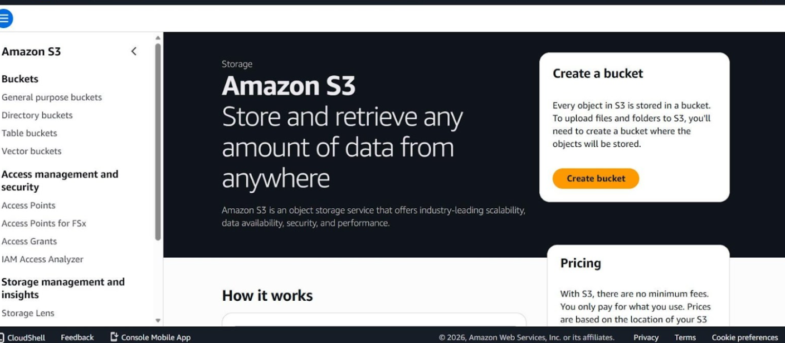
Step 2- Create Bucket.
- Choose General purpose as the bucket type.
- Select either Global namespace (default) or Account Regional namespace.
- Provide a unique name for the bucket.
- Scroll down to the Object Ownership section. Select ACLs enabled. All objects are owned by your AWS.

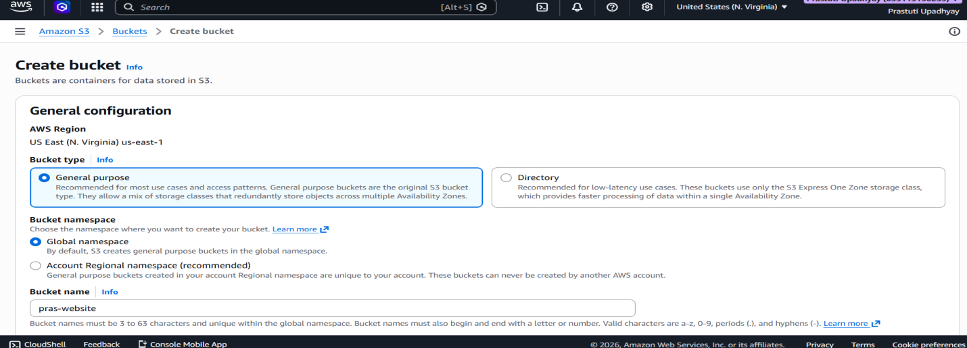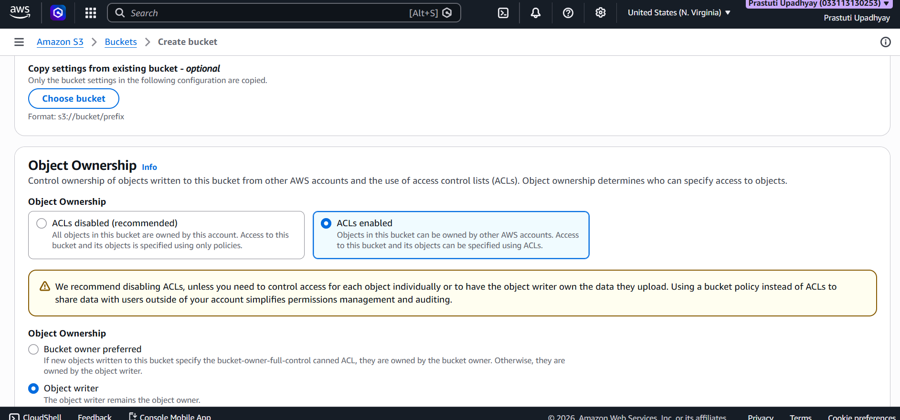
Step 3- Configure public access settings.
- Disable the option Block all public access by selecting the checkbox.
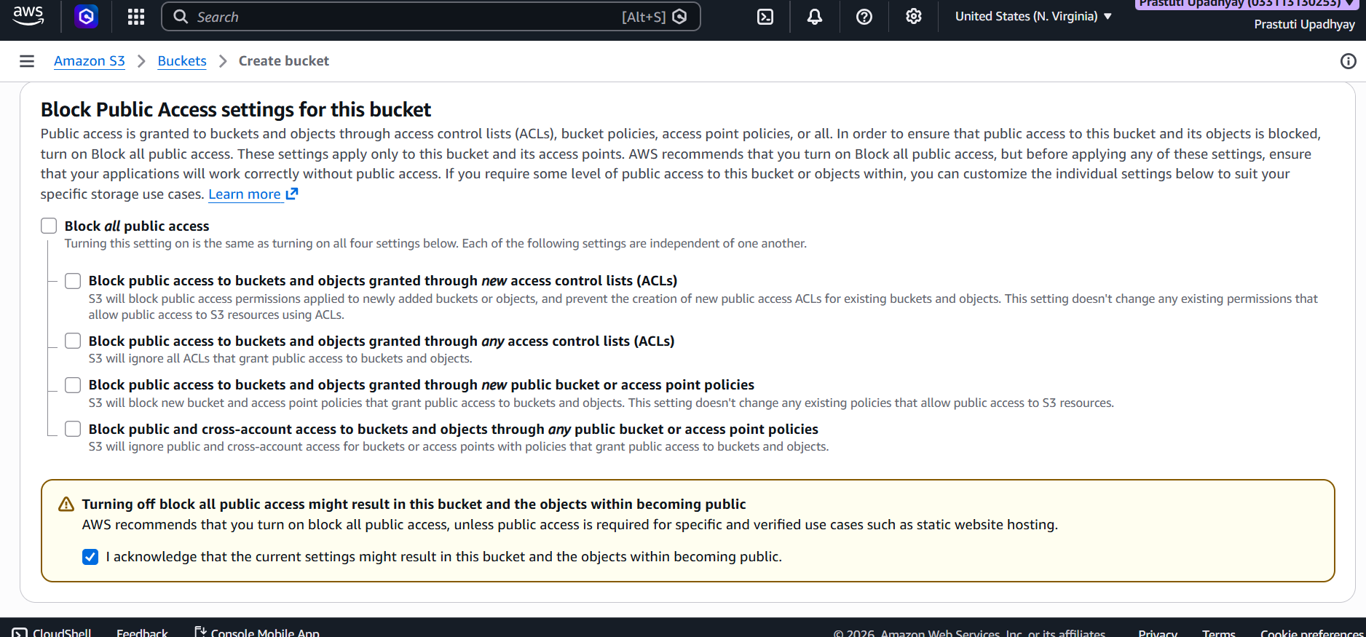
Step 4- Configure Bucket Version and Default Encryption.
- In Bucket Version select Disable.
- Navigate to the Default encryption section by scrolling down the page.

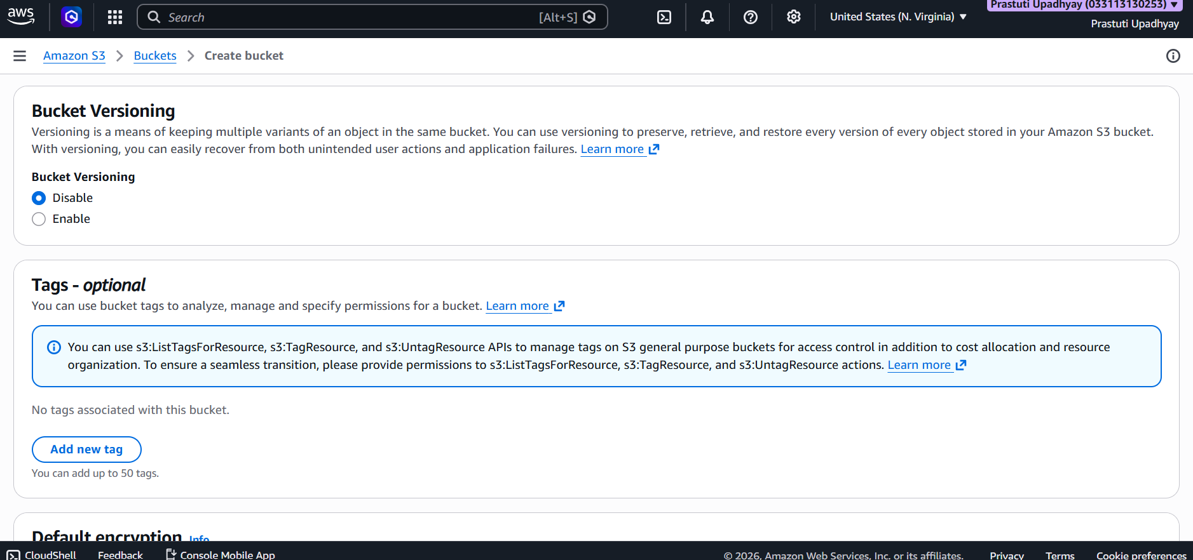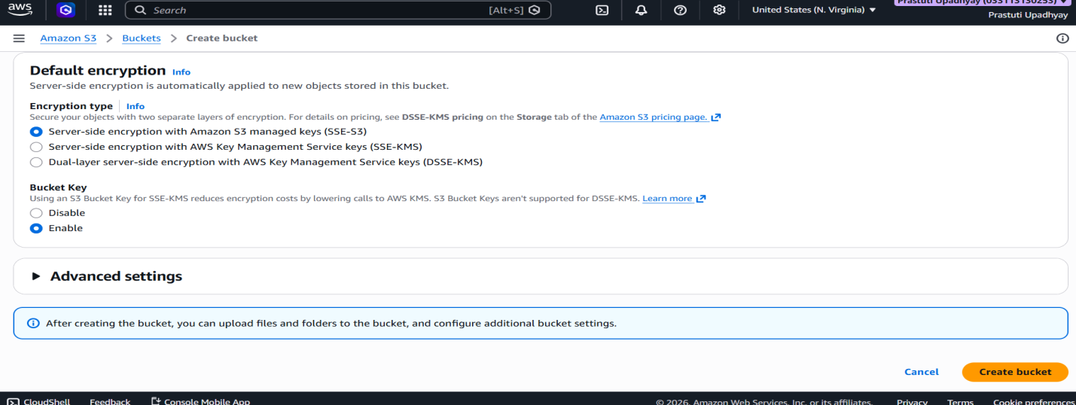
Step 5- Upload the file.
- Open your bucket and click on Upload.
- Drag and drop files, or use Add files / Add folder to select them.
- The selected files will be displayed in the list.
Verify the destination bucket, then click Upload to complete the process.
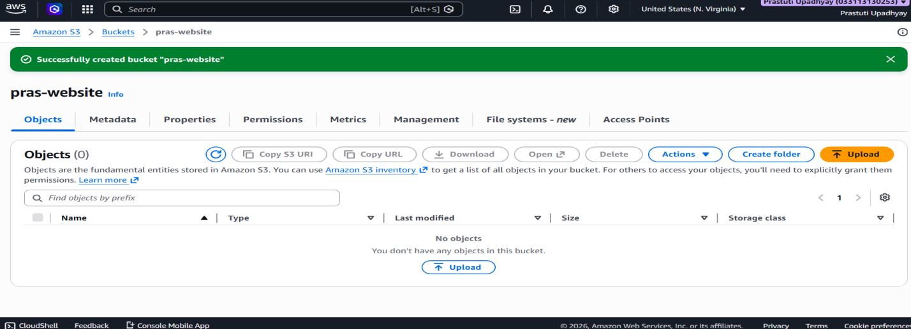
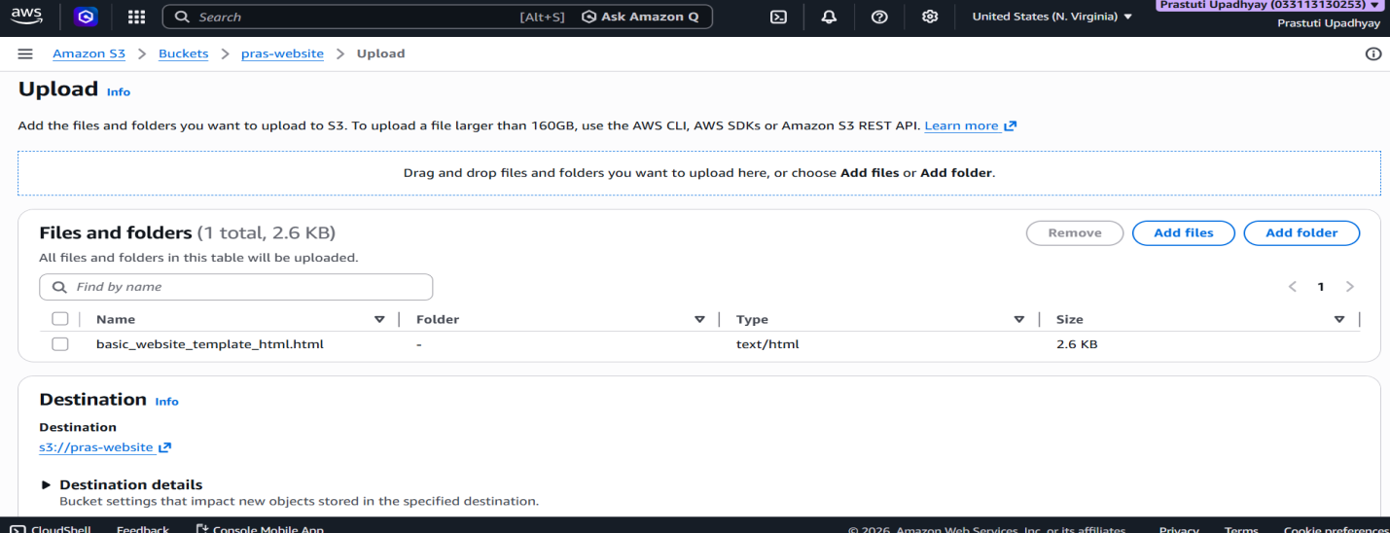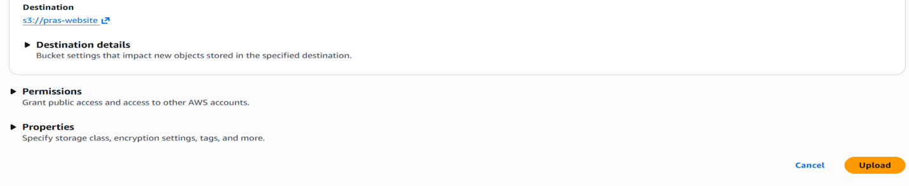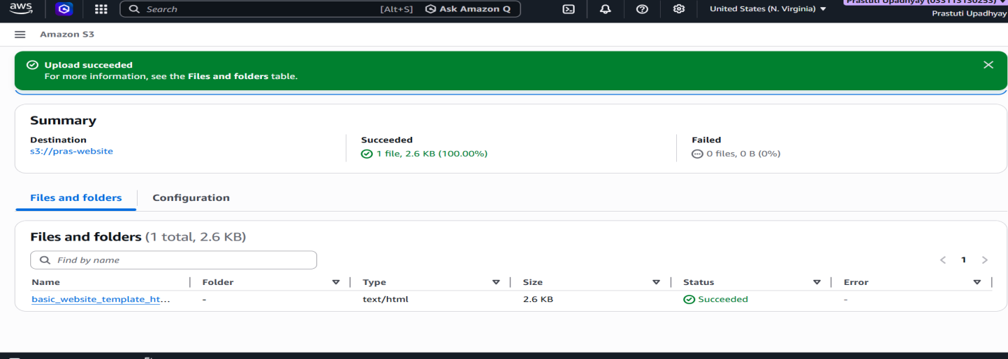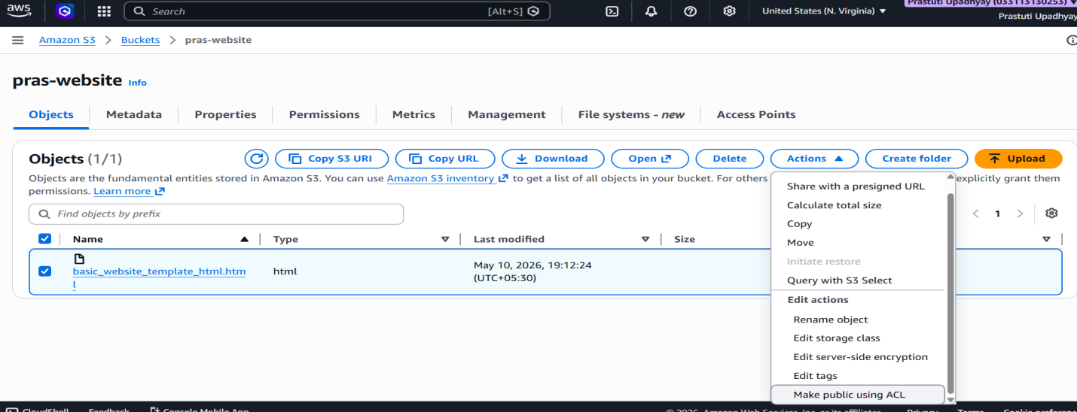

Step 6- Modify the Access Control List (ACL) to make the object publicly accessible.
